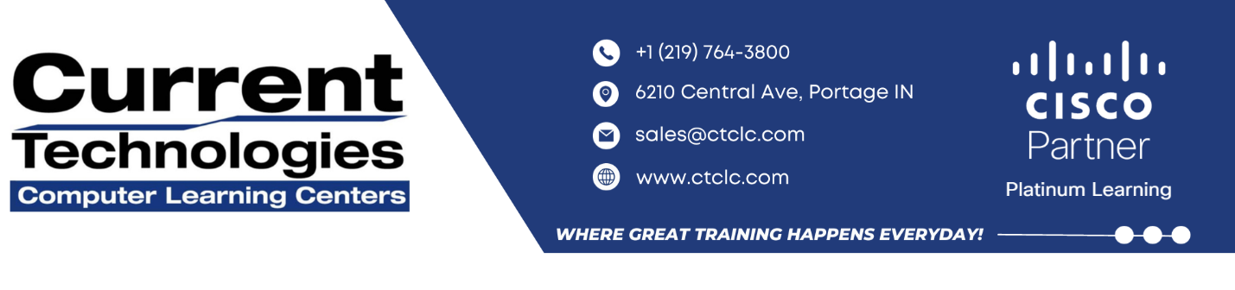

**IMPLEMENTING CISCO SD-WAN SECURITY AND CLOUD SOLUTIONS**

**(SDWSCS) V1.1**

**IMPLEMENTING CISCO SD-WAN SECURITY AND CLOUD SOLUTIONS (SDWSCS) V1.1**

The Implementing Cisco SD-WAN Security and Cloud Solutions (SDWSCS) V1.1 course is an advanced training course focused on Cisco SD-WAN security and cloud services. Through a series of labs and lectures you will learn about on-box security services, including application aware enterprise firewall, intrusion prevention, URL filtering, malware protection, and TLS or SSL decryption. You will also learn about cloud integration with multiple cloud services providers and multiple use-cases.

Additionally, the lab will allow you to configure and deploy local security services and cloud security services with the Cisco Umbrella Secure Internet Gateway (SIG), as well as integrate the Cisco SD-WAN fabric with a cloud service provider using the Cisco vManage automated workflows.

**How you’ll benefit**

This class will help you:

* Introduce you to the security and cloud services available in Cisco SD-WAN
* Expand your knowledge of integrated security services, such as the application aware firewall and intrusion prevention and cloud and collocated security services in on-premises and private or public cloud environments
* Help you understand drivers, benefits, available features, and the architecture of Cisco SD-WAN integrated and distributed security and cloud networking services

**Why Attend with Current Technologies CLC**

* Our Instructors are in the top 10% rated by Cisco
* Our Lab has a dedicated 1 Gig Fiber Connection for our Labs
* Our Labs run up to Date Code for all our courses

**Who Should Attend**

**Course Duration**

3 days

**Course Price**

$2,995.00 or 29 CLCs

**Methods of Delivery**

• Instructor Led

• Virtual ILT

• On-Site

The primary audience for this course is as follows:

* Network Engineers
* Network Security Engineers
* Network Architects
* Sales/presales Engineers

**OUTLINE**

**Module 1: Introducing Cisco SD-WAN Security**

**Module 2: Deploying On-Premises Threat Prevention**

**Module 3: Examining Content Filtering**

**Module 4: Exploring Cisco SD-WAN Dedicated Security Options**

**Module 5: Examining SASE**

**Module 6: Exploring Cisco Umbrella SIG**

**Module 7: Securing Cloud Applications with Cisco Umbrella SIG**

**Module 8: Exploring Cisco SD-Wan ThousandEyes**

**Module 9: Optimizing SaaS Applications**

**Module 10: Connecting Cisco SD-WAN to Public Cloud**

**Module 11: Examining Cloud Interconnect Solutions**

**Module 12: Exploring Cisco Cloud OnRamp for Colocation**

**Module 13: Monitoring Cisco SD-WAN Cloud and Security Solutions**

**LAB OUTLINE**

* **Lab 1: Configure Threat Prevention**
* **Lab 2: Implement Web Security**
* **Lab 3: Deploy DIA Security with Unified Security Policy**
* **Lab 4: Deploy Service Chaining**
* **Lab 5: Configure Cisco Umbrella DNS Policies**
* **Lab 6: Deploy Cisco Umbrella Secure Internet Gateway**
* **Lab 7: Implement CASB Security**
* **Lab 8: Microsoft 365 SaaS Testing by Using Cisco ThousandEyes**
* **Lab 9: Configure Cisco OnRamp for SaaS**