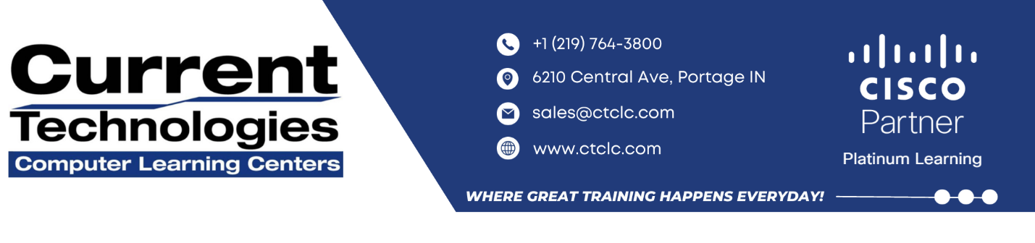

**IMPLEMENTING CISCO APPLICATION CENTRIC INFRASTRUCTURE–ADVANCED**

**(DCACIA) V1.2**

**IMPLEMENTING CISCO APPLICATION CENTRIC INFRASTRUCTURE–ADVANCED (DCACIA) V1.2**

The Implementing Cisco Application Centric Infrastructure–Advanced (DCACIA) v1.2 course shows you how to integrate the capabilities of the Cisco® Nexus® 9000 Series Switches in Cisco Application Centric Infrastructure (Cisco ACI®) mode. You will learn how to configure and manage Cisco Nexus 9000 Series Switches in ACI mode providing enhanced management and policy framework, along with the protocols used in the underlying fabric. The course also covers how to use Cisco ACI as a policy-driven solution that integrates software and hardware, and how to implement Cisco ACI Multi-Pod and Nexus Dashboard Orchestrator (NDO) deployments. You will gain hands-on practice implementing advanced ACI capabilities such as Rogue Endpoint Feature, Transit Routing, VRF Route Leaking, Contracts and Zoning Rules, Policy Based Redirect to Layer 4–7 Service Node, Multi-Pod Fabric and Cisco ACI® Nexus Dashboard Orchestrator.

**How you’ll benefit**

This class will help you:

* Gain the skills and hands-on practice integrating the enhanced, automated capabilities of Cisco Nexus 9000 Series Switches in ACI mode for quicker application deployment
* Get the knowledge for protocols, solutions and designs to acquire professional-level and expert-level data center job roles
* Earn 40 CE credits toward recertification

**Why Attend with Current Technologies CLC**

* Our Instructors are in the top 10% rated by Cisco
* Our Lab has a dedicated 1 Gig Fiber Connection for our Labs
* Our Labs run up to Date Code for all our courses

**Who Should Attend**

**Course Duration**

5 days

**Course Price**

$4,495.00 or 45 CLCs

**Methods of Delivery**

• Instructor Led

• Virtual ILT

• On-Site

The primary audience for this course is as follows:

* Network Designers
* Network Administrators
* Network Engineers
* Systems Engineers
* Data Center Engineers
* Consulting Systems Engineers
* Technical Solutions Architects
* Cisco Integrators/Partners
* Field Engineers
* Server Administrators
* Network Managers
* Storage Administrators
* Cisco Integrators and Partners

**OUTLINE**

**Module 1: Describing Cisco ACI Advanced Packet Forwarding**

**Module 2: Using Advanced Cisco ACI Policy and Tenant Configuration**

**Module 3: Implementing Traditional Network in Cisco ACI**

**Module 4: Describing Cisco ACI Service Graph PBR**

**Module 5: Describing Cisco ACI Multi-Pod Deployment**

**Module 6: Describing Cisco ACI Multi-Site Deployment**

**LAB OUTLINE**

* **Lab 1: Examine Local and Remote Endpoint Learning**
* **Lab 2: Verify Bounce Entries**
* **Lab 3: Validate IP Learning**
* **Lab 4: Mitigate IP and MAC Flapping with the Rogue Endpoint Feature**
* **Lab 5: Enable Transit Routing**
* **Lab 6: Implement VRF Route Leaking**